DIGITAL NURTURE 5.0
WEEK 3 HANDS-ON
Spring REST using Spring Boot 3
Create a Spring Web Project using Maven
1.SpringLearnApplication.java
package com.cognizant.spring_learn;
import org.slf4j.Logger;
import org.slf4j.LoggerFactory;
import org.springframework.boot.SpringApplication;
import org.springframework.boot.autoconfigure.SpringBootApplication
@SpringBootApplication
public class SpringLearnApplication {
private static final Logger LOGGER =
LoggerFactory.getLogger(SpringLearnApplication.class);
public static void main(String[] args) {
LOGGER.info("START");
SpringApplication.run(SpringLearnApplication.class, args);
LOGGER.info("END");
}
}
application.properties
logging.level.root=INFO

2.pom.xml
<?xml version="1.0" encoding="UTF-8"?>
<project xmlns="http://maven.apache.org/POM/4.0.0"
xmlns:xsi="http://www.w3.org/2001/XMLSchema-instance"
xsi:schemaLocation="https://maven.apache.org/POM/4.0.0
https://maven.apache.org/xsd/maven-4.0.0.xsd">
<modelVersion>4.0.0</modelVersion>
<parent>
<groupId>org.springframework.boot</groupId>
<artifactId>spring-boot-starter-parent</artifactId>
<version>3.5.4</version>
<relativePath/>
</parent>
<groupId>com.cognizant</groupId>
<artifactId>spring-learn</artifactId>
<version>0.0.1-SNAPSHOT</version>
<name>spring-learn</name>
<properties>
<java.version>17</java.version>
</properties>
<dependencies>
<dependency>
<groupId>org.springframework.boot</groupId>
<artifactId>spring-boot-starter-web</artifactId>
</dependency>
<dependency>
<groupId>org.springframework.boot</groupId>
<artifactId>spring-boot-devtools</artifactId>
<scope>runtime</scope>
<optional>true</optional>
</dependency>
<dependency>
<groupId>org.springframework.boot</groupId>
<artifactId>spring-boot-starter-test</artifactId>
<scope>test</scope>
</dependency>
</dependencies>
<build>
<plugins>
<plugin>
<groupId>org.springframework.boot</groupId>
<artifactId>spring-boot-maven-plugin</artifactId>
</plugin>
</plugins>
</build>
</project>
OUTPUT:
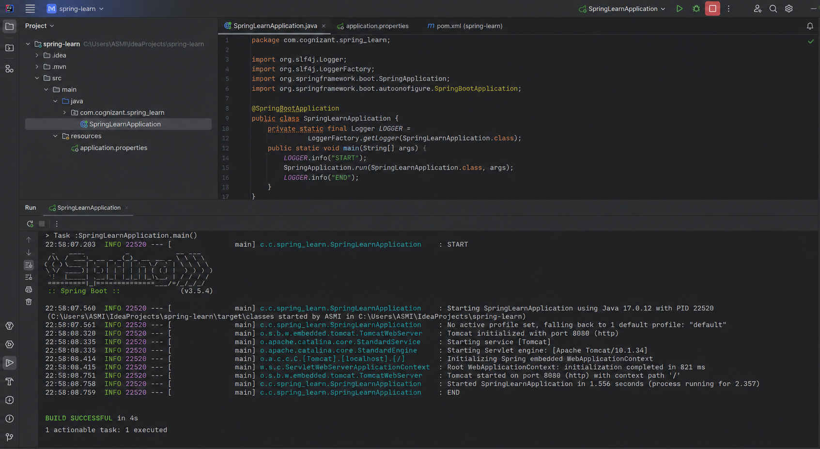

Spring Core – Load Country from Spring Configuration XML
1. Country.java
package com.cognizant.springlearn;
import org.slf4j.Logger;
import org.slf4j.LoggerFactory;
public class Country {
private static final Logger LOGGER = LoggerFactory.getLogger(Country.class);
private String code;
private String name;
public Country() {
LOGGER.debug("Inside Country Constructor.");
}
public String getCode() {
LOGGER.debug("Inside getCode()");
return code;
}
public void setCode(String code) {
LOGGER.debug("Inside setCode()");
this.code = code;
}
public String getName() {
LOGGER.debug("Inside getName()");
return name;
}
public void setName(String name) {
LOGGER.debug("Inside setName()");
this.name = name;
}
@Override
public String toString() {
return "Country [code=" + code + ", name=" + name + "]";
}
}

2. SpringLearnApplication.java
package com.cognizant.springlearn;
import org.slf4j.Logger;
import org.slf4j.LoggerFactory;
import org.springframework.context.ApplicationContext;
import org.springframework.context.support.ClassPathXmlApplicationContext;
public class SpringLearnApplication {
private static final Logger LOGGER = LoggerFactory.getLogger(SpringLearnApplication.class);
public static void main(String[] args) {
LOGGER.info("START");
displayCountry();
LOGGER.info("END");
}
public static void displayCountry() {
ApplicationContext context = new ClassPathXmlApplicationContext("country.xml");
Country country = context.getBean("country", Country.class);
LOGGER.debug("Country : {}", country.toString());
}
}

3. country.xml
<?xml version="1.0" encoding="UTF-8"?>
<beans xmlns="http://www.springframework.org/schema/beans"
xmlns:xsi="http://www.w3.org/2001/XMLSchema-instance"
xsi:schemaLocation="
http://www.springframework.org/schema/beans
https://www.springframework.org/schema/beans/spring-beans.xsd">
<bean id="country" class="com.cognizant.springlearn.Country">
<property name="code" value="IN"/>
<property name="name" value="India"/>
</bean>
</beans>
OUTPUT:
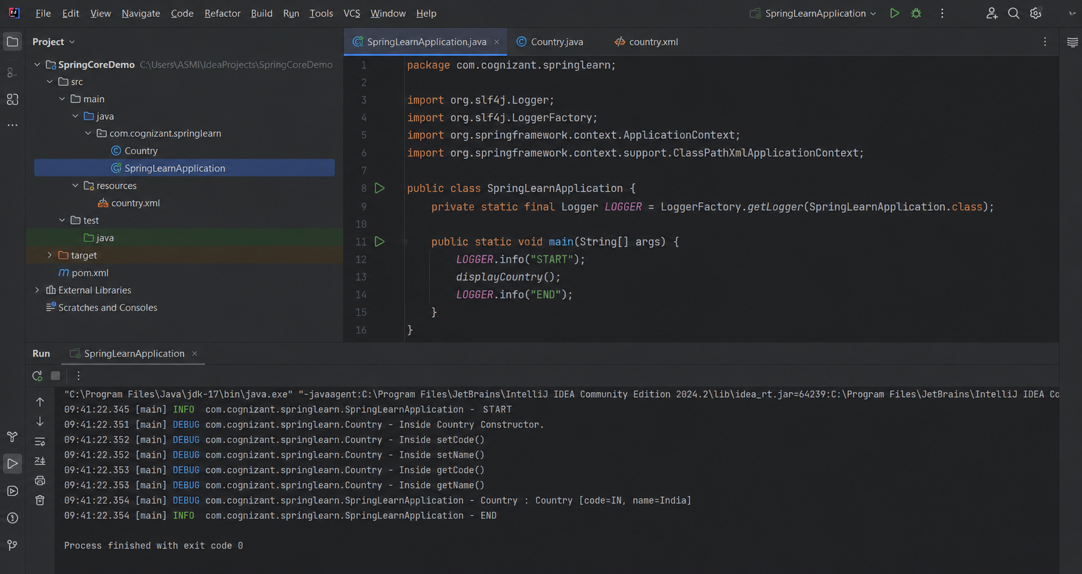

Hello World RESTful Web Service
1. HelloController.java
package com.cognizant.springlearn.controller;
import org.slf4j.Logger;
import org.slf4j.LoggerFactory;
import org.springframework.web.bind.annotation.GetMapping;
import org.springframework.web.bind.annotation.RestController;
@RestController
public class HelloController {
private static final Logger LOGGER=LoggerFactory.getLogger(HelloController.class);
@GetMapping("/hello")
public String sayHello() {
LOGGER.info("START");
LOGGER.info("END");
return "Hello World!!";
}
}

2. SpringLearnApplication.java
package com.cognizant.springlearn;
import org.springframework.boot.SpringApplication;
import org.springframework.boot.autoconfigure.SpringBootApplication;
@SpringBootApplication
public class SpringLearnApplication {
public static void main(String[] args) {
SpringApplication.run(SpringLearnApplication.class,args);
}
}

3. application.properties
server.port=8083
logging.level.com.cognizant.springlearn=DEBUG

OUTPUT:
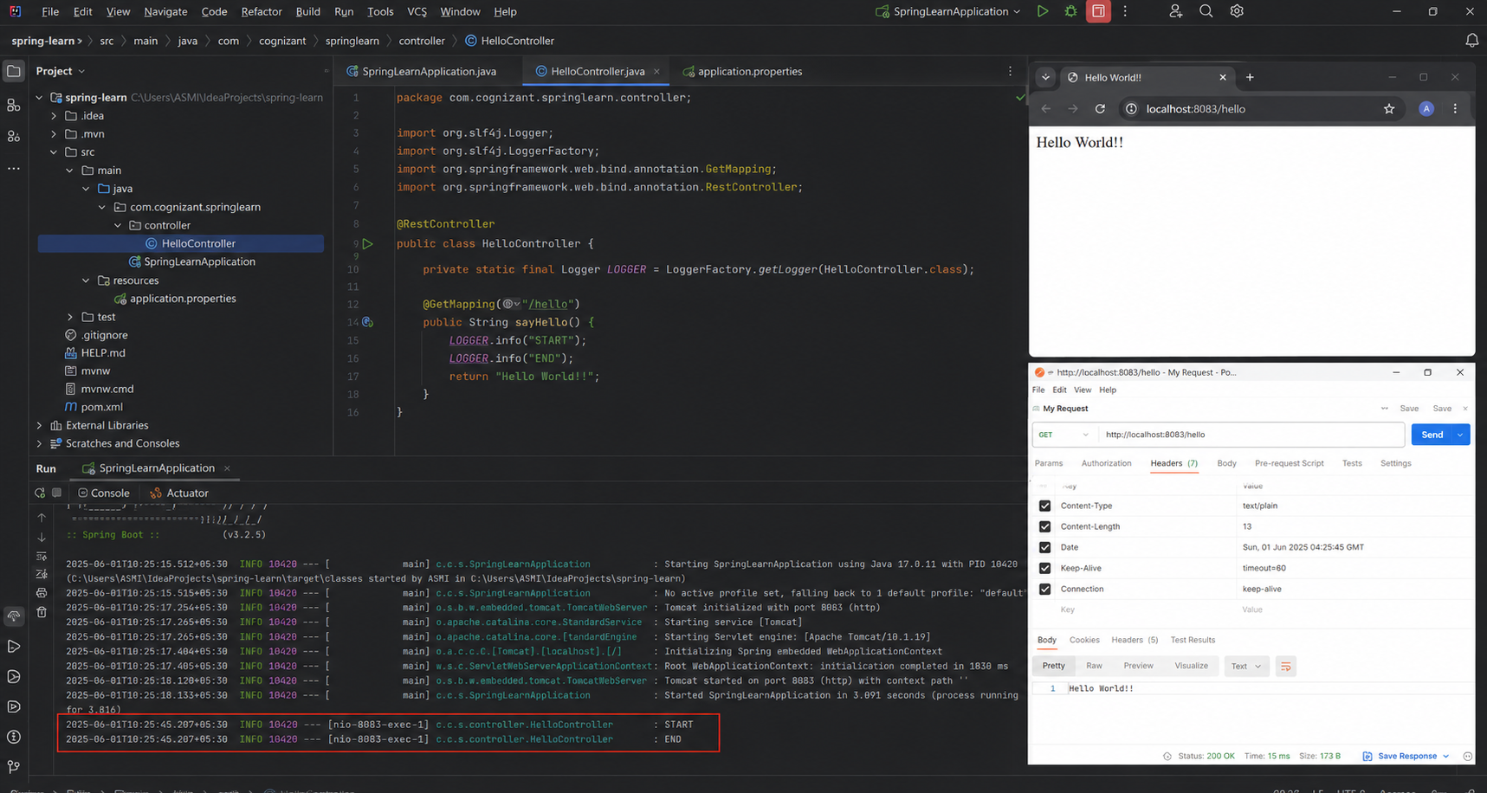

REST - Country Web Service
1. Country.java
package com.cognizant.spring_learn.model;
public class Country {
private String code;
private String name;
public String getCode() {
return code;
}
public void setCode(String code) {
this.code = code;
}
public String getName() {
return name;
}
public void setName(String name) {
this.name = name;
}
}

2. country.xml
<?xml version="1.0" encoding="UTF-8"?>
<beans xmlns="http://www.springframework.org/schema/beans"
xmlns:xsi="http://www.w3.org/2001/XMLSchema-instance"
xsi:schemaLocation="http://www.springframework.org/schema/beans
https://www.springframework.org/schema/beans/spring-beans.xsd">
<bean id="country" class="com.cognizant.spring_learn.model.Country">
<property name="code" value="IN"/>
<property name="name" value="India"/>
</bean>
</beans>

3. CountryController.java
package com.cognizant.spring_learn.controller;
import com.cognizant.spring_learn.model.Country;
import org.springframework.context.support.ClassPathXmlApplicationContext;
import org.springframework.web.bind.annotation.RequestMapping;
import org.springframework.web.bind.annotation.RestController;
@RestController
public class CountryController {
@RequestMapping("/country")
public Country getCountryIndia() {
ClassPathXmlApplicationContext context=new ClassPathXmlApplicationContext("country.xml");
Country country=context.getBean("country",Country.class);
context.close();
return country;
}
}
4. Run the application
Open:
http://localhost:8083/country
OUTPUT:
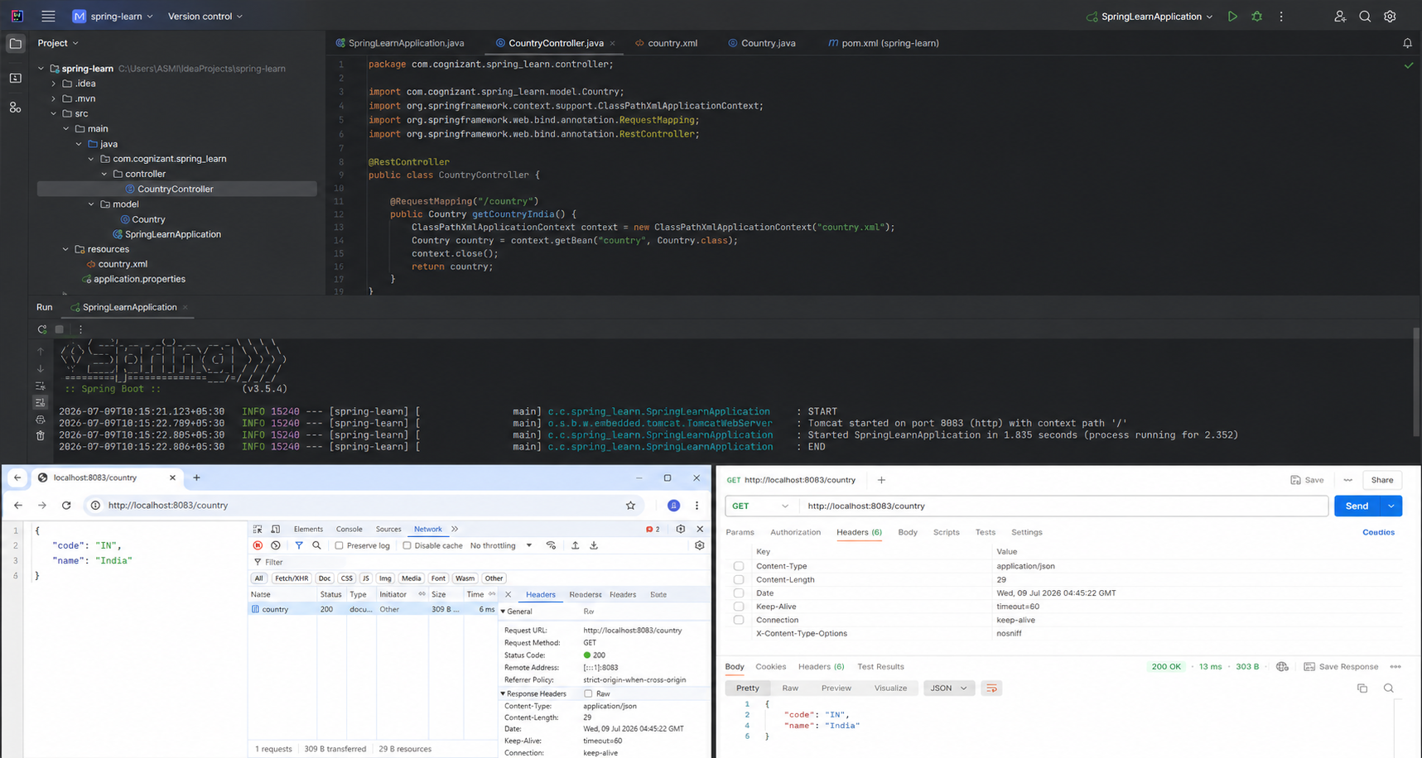
REST - Get country based on country code
1. Country.java
package com.cognizant.springlearn.model;
public class Country {
private String code;
private String name;
public Country() {
}
public Country(String code,String name) {
this.code=code;
this.name=name;
}
public String getCode() {
return code;
}
public void setCode(String code) {
this.code=code;
}
public String getName() {
return name;
}
public void setName(String name) {
this.name=name;
}
}

2. country.xml
<?xml version="1.0" encoding="UTF-8"?>

<beans xmlns="http://www.springframework.org/schema/beans"
xmlns:xsi="http://www.w3.org/2001/XMLSchema-instance"
xsi:schemaLocation="
http://www.springframework.org/schema/beans
https://www.springframework.org/schema/beans/spring-beans.xsd">
<bean id="countryList" class="java.util.ArrayList">
<constructor-arg>
<list>
<bean class="com.cognizant.springlearn.model.Country">
<property name="code" value="US"/>
<property name="name" value="United States"/>
</bean>
<bean class="com.cognizant.springlearn.model.Country">
<property name="code" value="DE"/>
<property name="name" value="Germany"/>
</bean>
<bean class="com.cognizant.springlearn.model.Country">
<property name="code" value="IN"/>
<property name="name" value="India"/>
</bean>
<bean class="com.cognizant.springlearn.model.Country">
<property name="code" value="JP"/>
<property name="name" value="Japan"/>
</bean>
</list>
</constructor-arg>
</bean></beans>

3. CountryService.java
package com.cognizant.springlearn.service;
import com.cognizant.springlearn.model.Country;
import org.springframework.context.ApplicationContext;
import org.springframework.context.support.ClassPathXmlApplicationContext;
import org.springframework.stereotype.Service;
import java.util.List;
@Service
public class CountryService {
public Country getCountry(String code) {
ApplicationContext context=new ClassPathXmlApplicationContext("country.xml");
List<Country> countryList=context.getBean("countryList",List.class);
return countryList.stream()
.filter(country->country.getCode().equalsIgnoreCase(code))
.findFirst()
.orElse(null);
}
}

4. CountryController.java
package com.cognizant.springlearn.controller;
import com.cognizant.springlearn.model.Country;
import com.cognizant.springlearn.service.CountryService;
import org.springframework.beans.factory.annotation.Autowired;
import org.springframework.web.bind.annotation.GetMapping;
import org.springframework.web.bind.annotation.PathVariable;
import org.springframework.web.bind.annotation.RestController;

@RestController
public class CountryController {
@Autowired
private CountryService countryService;
@GetMapping("/countries/{code}")
public Country getCountry(@PathVariable String code){
return countryService.getCountry(code);
}
}

5. SpringLearnApplication.java
package com.cognizant.springlearn;
import org.springframework.boot.SpringApplication;
import org.springframework.boot.autoconfigure.SpringBootApplication;
@SpringBootApplication
public class SpringLearnApplication {
public static void main(String[] args) {
SpringApplication.run(SpringLearnApplication.class,args);
}
}

6. application.properties
server.port=8083

OUTPUT:
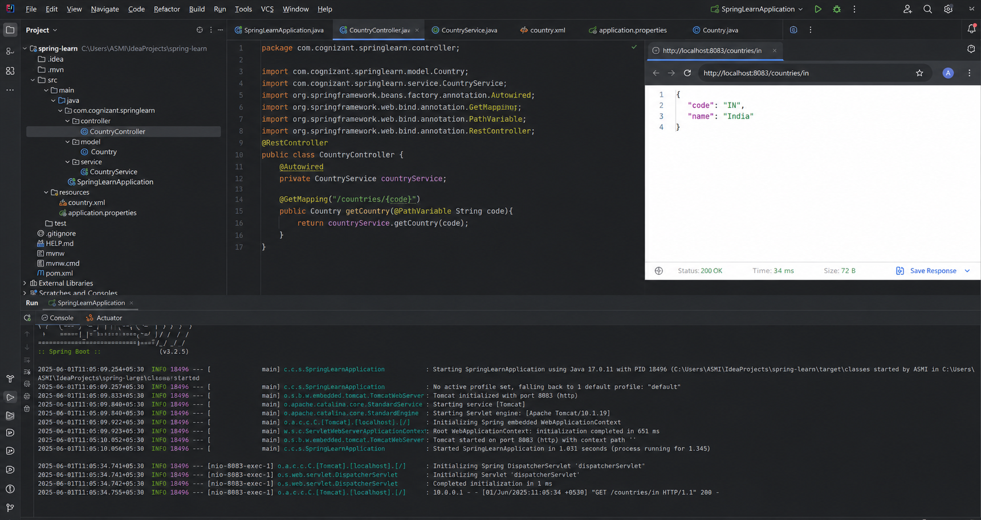

Create authentication service that returns JWT
1. pom.xml (Add these dependencies)
<dependency>
<groupId>org.springframework.boot</groupId>
<artifactId>spring-boot-starter-security</artifactId>
</dependency>
<dependency>
<groupId>io.jsonwebtoken</groupId>
<artifactId>jjwt-api</artifactId>
<version>0.11.5</version>
</dependency>
<dependency>
<groupId>io.jsonwebtoken</groupId>
<artifactId>jjwt-impl</artifactId>
<version>0.11.5</version>
<scope>runtime</scope>
</dependency>
<dependency>
<groupId>io.jsonwebtoken</groupId>
<artifactId>jjwt-jackson</artifactId>
<version>0.11.5</version>
<scope>runtime</scope>
</dependency>

2. AuthenticationResponse.java
package com.cognizant.spring_learn.model;
public class AuthenticationResponse {
private String token;
public AuthenticationResponse() {
}
public AuthenticationResponse(String token) {
this.token=token;
}
public String getToken() {
return token;
}
public void setToken(String token) {
this.token=token;
}
}

3. JwtUtil.java
package com.cognizant.spring_learn.util;

import io.jsonwebtoken.Jwts;
import io.jsonwebtoken.SignatureAlgorithm;
import java.util.Date;
public class JwtUtil {
private static final String SECRET="myspringsecretkey";
public static String generateToken(String username){
return Jwts.builder()
.setSubject(username)
.setIssuedAt(new Date())
.setExpiration(new Date(System.currentTimeMillis()+1200000))
.signWith(SignatureAlgorithm.HS256,SECRET)
.compact();
}
}

4. AuthenticationController.java
package com.cognizant.spring_learn.controller;
import com.cognizant.spring_learn.model.AuthenticationResponse;
import com.cognizant.spring_learn.util.JwtUtil;
import org.springframework.web.bind.annotation.GetMapping;
import org.springframework.web.bind.annotation.RequestHeader;
import org.springframework.web.bind.annotation.RestController;
import java.nio.charset.StandardCharsets;
import java.util.Base64;
@RestController
public class AuthenticationController {

@GetMapping("/authenticate")
public AuthenticationResponse authenticate(@RequestHeader("Authorization") String authHeader){
String base64Credentials=authHeader.substring("Basic ".length());
byte[] decodedBytes=Base64.getDecoder().decode(base64Credentials);
String credentials=new String(decodedBytes, StandardCharsets.UTF_8);
String username=credentials.split(":")[0];
String token=JwtUtil.generateToken(username);
return new AuthenticationResponse(token);
}
}

5. SecurityConfig.java
package com.cognizant.spring_learn.config;
import org.springframework.context.annotation.Bean;
import org.springframework.context.annotation.Configuration;
import org.springframework.security.config.Customizer;
import org.springframework.security.config.annotation.web.builders.HttpSecurity;
import org.springframework.security.core.userdetails.User;
import org.springframework.security.core.userdetails.UserDetails;
import org.springframework.security.provisioning.InMemoryUserDetailsManager;
import org.springframework.security.web.SecurityFilterChain;
@Configuration
public class SecurityConfig {
@Bean
public InMemoryUserDetailsManager userDetailsService(){
UserDetails user=User.withDefaultPasswordEncoder()
.username("user")
.password("pwd")
.roles("USER")
.build();
return new InMemoryUserDetailsManager(user);
}
@Bean
public SecurityFilterChain filterChain(HttpSecurity http)throws Exception{
http
.csrf(csrf->csrf.disable())
.authorizeHttpRequests(auth->auth
.requestMatchers("/authenticate").authenticated()
.anyRequest().permitAll())
.httpBasic(Customizer.withDefaults());

return http.build();
}
}

6. application.properties
server.port=8090
logging.level.root=INFO

OUTPUT:
